SOC Practical Task Report

Name : Abhishek Ramesh

Organization : CyArt
Date : 6th March

1.Alert Classification

Objective
The objective of this task is to understand how security alerts are categorized and prioritized in a Security Operations Center (SOC). Alerts are analyzed based on severity, potential impact, and associated attack techniques.

Alert Classification Table
Alert ID | Alert Type | Priority | MITRE Technique
001 | Phishing Email | High | T1566
002 | Brute Force SSH | Medium | T1110
003 | Malware Detected | Critical | T1204
004 | Port Scan | Low | T1046

Explanation
Security alerts are classified based on their potential impact on the organization.
Critical alerts represent severe threats such as ransomware infections or system compromise. High-priority alerts indicate possible unauthorized access or phishing attempts. Medium alerts represent suspicious activity that requires investigation, while low-priority alerts include reconnaissance activities like port scanning.

2. Alert Triage
Objective
Alert triage is the process of analyzing security alerts to determine their severity and validity. SOC analysts review alerts and determine whether they represent a real threat or a false positive.

Alert Triage Table
Alert ID | Description | Source IP | Priority | Status
002 | Brute-force SSH attempts | 192.168.1.100 | Medium | Open
003 | Suspicious login activity | 10.0.0.5 | High | Investigating

Investigation Steps
- Review security logs in the Wazuh dashboard.
- Verify suspicious IP addresses using threat intelligence platforms such as VirusTotal.
- Check indicators of compromise using AlienVault OTX.
- Escalate confirmed threats to higher-level SOC analysts.

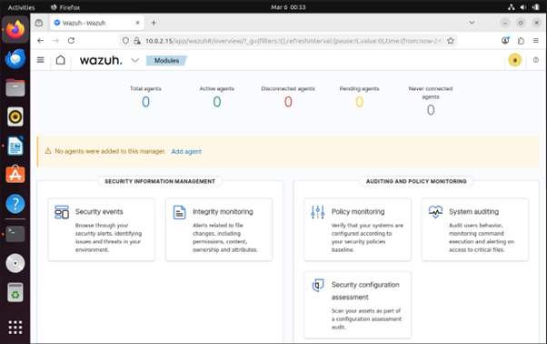

3. Incident Response
Objective
Incident response involves identifying, containing, and resolving security incidents to minimize damage to the organization.

Executive Summary
A suspicious login activity was detected by the Wazuh security monitoring system. The event was flagged as a potential brute-force attack attempt targeting a system within the monitored environment.

Incident Timeline
Time | Action
10:00 AM | Alert detected by Wazuh
10:05 AM | SOC analyst reviewed logs
10:10 AM | Suspicious IP investigated
10:15 AM | Endpoint isolated

Remediation Steps
- Block the malicious IP address using firewall rules.
- Reset compromised credentials.
- Update system security policies.
- Monitor the system for further suspicious activities.

Lessons Learned
Early detection through SIEM monitoring significantly improves the response time and reduces the impact of security incidents.


4. Incident Ticket
Incident Details
Title: [High Priority] Suspicious Login Attempt Detected
Description:
Multiple login attempts were detected from an unknown IP address. The activity triggered an alert in the monitoring system indicating a possible brute-force attack.
Indicators of Compromise:
IP Address: 192.168.1.100
Event Type: Brute Force Login Attempt
Priority Level: High
Assigned To: SOC Analyst
Status: Under Investigation

5. Evidence Preservation
Objective
Evidence preservation ensures that digital evidence is collected and stored securely without modification so it can be used during investigations.

Evidence Log
Item | Description | Collected By | Date | Hash Value
Alert Logs | Wazuh alerts.json file | SOC Analyst | 2026-03-06 | SHA256 Hash

Procedure
- Identify relevant log files containing security alerts.
- Copy logs from the monitored system.
- Generate a cryptographic hash to ensure integrity.
- Store evidence in a secure repository.

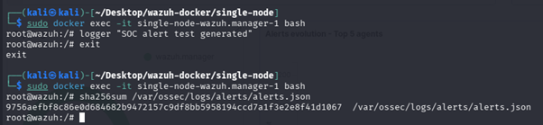

6. Wazuh Monitoring Dashboard
Tool Used
Security monitoring was performed using Wazuh, deployed using Docker on Kali Linux.

Purpose
Wazuh provides real-time security monitoring by analyzing logs and detecting suspicious activity within a system.

Observations
The dashboard displays security alerts, system monitoring information, and event logs. It helps SOC analysts quickly identify and respond to potential threats.

Wazuh Dashboard Overview
- Wazuh Security Events
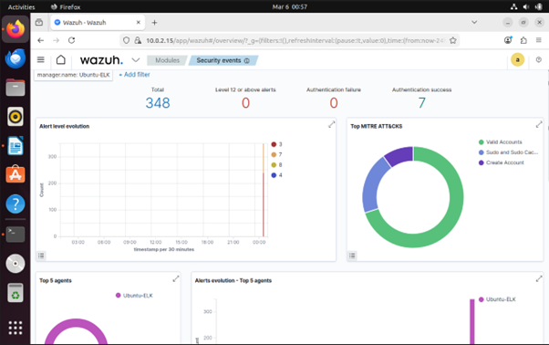

- Wazuh Agents Page
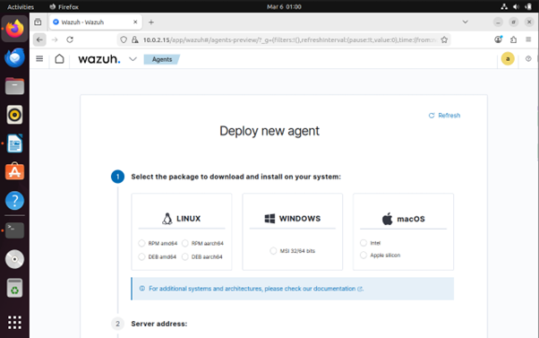

7. Conclusion
This exercise demonstrated the core responsibilities of a SOC analyst, including alert monitoring, incident classification, investigation, and response. The Wazuh SIEM platform was used to monitor system activity and detect potential security threats. Proper alert triage and incident response procedures help organizations minimize security risks and improve overall cyber defense capabilities.

